Apache Tomcat 9 Server Installation

Procedure
Step 1: Switch to Root User
sudo -i

Step 2: Update and Upgrade System Packages
sudo apt update && sudo apt upgrade -y

Step 3: Navigate to /tmp Directory
cd /tmp

Step 4: Download Apache Tomcat 9.0.95
wget https://archive.apache.org/dist/tomcat/tomcat-9/v9.0.95/bin/apache-tomcat-9.0.95.tar.gz

Step 5: Navigate to /opt and Create tomcat Directory
cd ..
cd opt
ls
mkdir tomcat

Step 6: Extract Tomcat Archive into /opt/tomcat
cd ..
cd tmp
sudo tar -xvzf apache-tomcat-9.0.95.tar.gz -C /opt/tomcat --strip-components=1

Step 7: Verify the Extracted Files
cd ..
cd opt/tomcat
ls

Step 8: Configure Server Port in server.xml
cd conf
ls
gedit server.xml
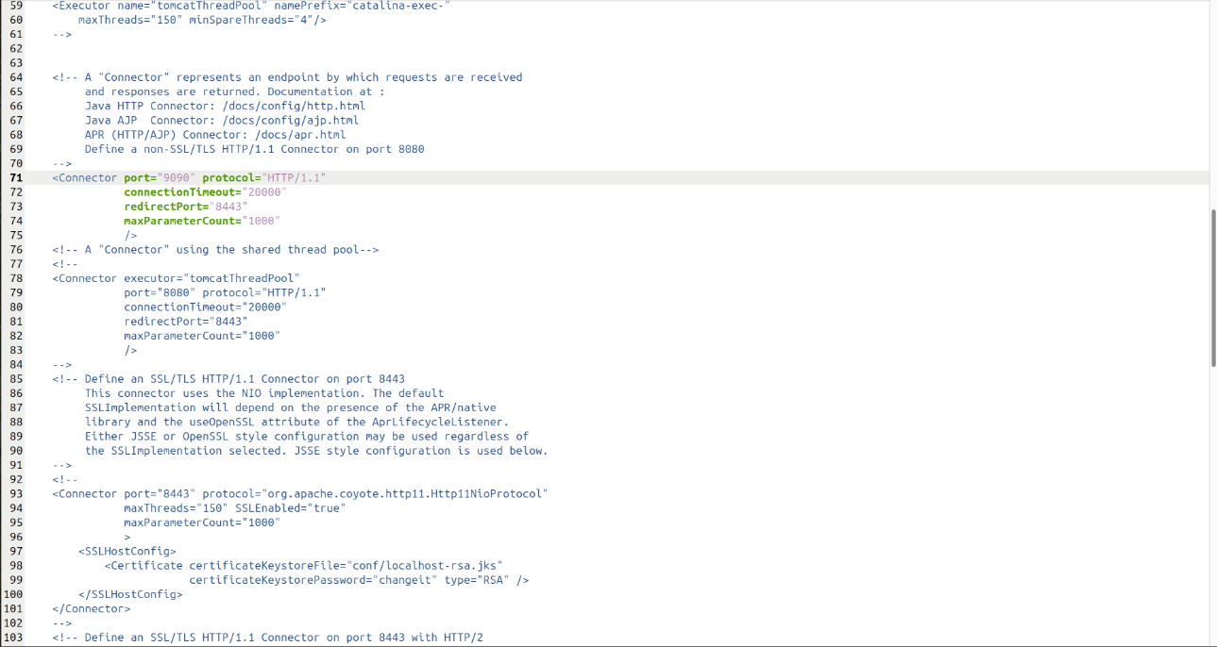
At line 71, change the Connector port number to 9090

Step 9: Add Admin User in tomcat-users.xml
gedit tomcat-users.xml
At line 22, inside <tomcat-users>, add the following:
<user username="admin" password="Admin" roles="manager-gui"/>
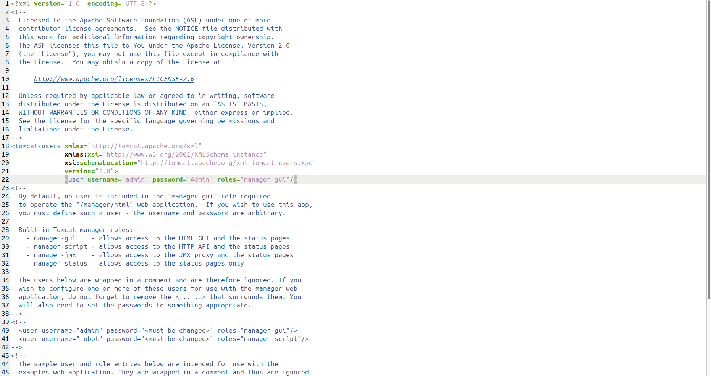

Step 10: Start the Tomcat Server
cd ..
cd bin
ls
sh startup.sh

Step 11: Open Tomcat in Web Browser
Search localhost:9090 in web browser to open the server.
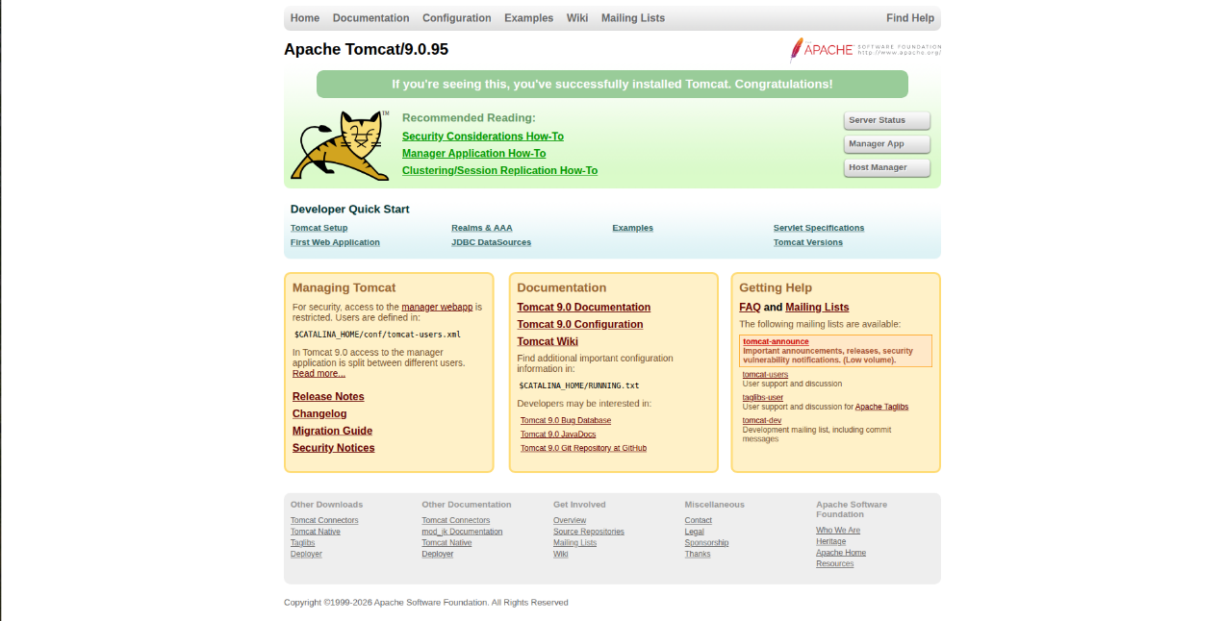

Click on Manager App and enter the configured credentials to log in.
Username: admin
Password: Admin
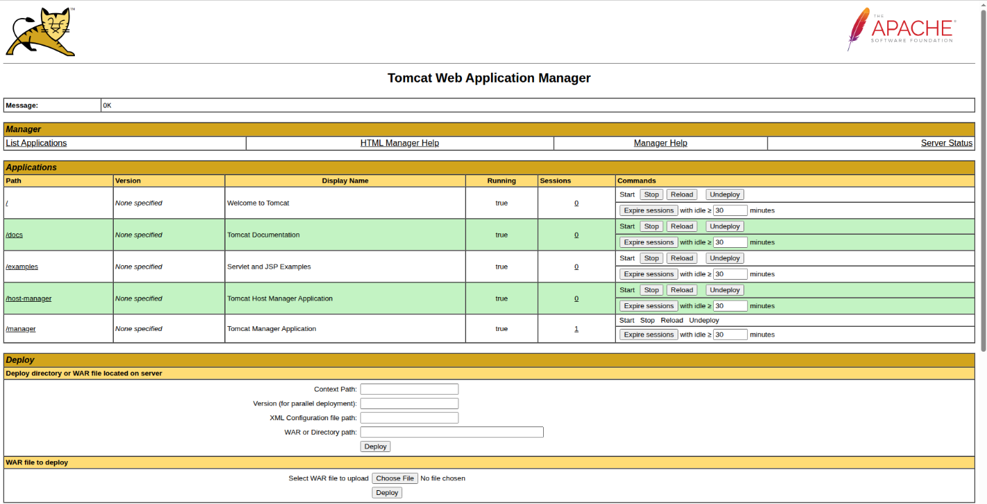

To Stop the Tomcat Server:
cd /opt/tomcat/bin
sh shutdown.sh

